Student’s name | …………………………………………………….…… | Grade | 4
Subject | Computer | Week No. | 10
Lesson Title | Presentation | Unit
Worksheet No. ( 10 ) (Answer)
Question A:

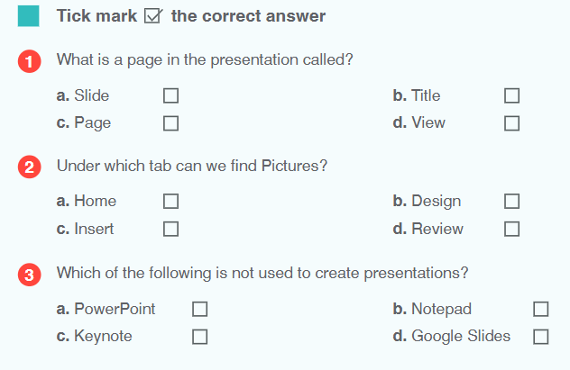
✔️
✔️
✔️
Good Luck

